Focus: Mobile text entry with the right hand preferably on an iPhone, specifically regarding fixing typos, switching between numbers/letters, and switching languages.

Goal

* Continue exploring and understanding the context
* Observe and interview stakeholders to identify what tasks they perform to accomplish their goals and any breakdowns with their existing tasks

Use Miro Board

Individual Instructions

* Conduct contextual inquiry with 1 participant
* Take notes during the interview and use them to create interpretations
* Create at least 1 sequence diagram
  + 1 sequence diagram per task which the user performs
  + there may be multiple tasks that should be captured in different sequence diagrams
* Create 1 flow diagram
* Write report
  + the focus
  + the method you used [write in group] your design, de-identified information about your participant
    - Example from lecture [~45 minutes]
    - How we conducted the contextual inquiry, what protocol, why used them, who were the participants, what were the tasks/procedures
    - Each of the team members interviewed 1 participant about the focus of ____ at _____ location
    - Informed participants about the purpose of the study (interview) and the tasks they are going to perform (responding to questions asked by interviewer), explain their participation is fully voluntary
    - the investigators then proceed to ask questions about participant’s existing experience about the focus
    - investigator continue to ask questions based on participant’s responses
    - Once the interview is concluded, the investigator thanked the participant and conducted a follow-up interpretation with the team and consolidated the diagrams etc.
  + individual results
    - from this single participant
  + all individual interpretations
    - make sure each teammate use a different encoding for their participant
      * U01 to U06
  + one or more sequence models for each interview
  + one flow diagram for each interview

Contextual Inquiry

* What
  + Principled
    - 1. Context: being in the context to understand the context of use
    - 2. Partnership: clearly tell the participant that they are the expert
      * no right or wrong answer, just need to describe their experience
    - 3. Interpretation: participant describe their tasks, interviewer interprets them at the same time during the interview
    - 4. Focus: the existing focus coming into the interview can narrow, broaden, or even shift during/after the interview
  + Unstructured
    - No preconceived questions coming into the interview
    - All questions asked during the interview depend on the context, the participant, and many factors
  + Brings designers into the field & Gather field data (qualitative)
  + Observe the environment, interview the participant
  + Each session lasts approximately 1 to 2 hours
* How
  + 1. Designer/Interviewer interviews the participant/user at the location (environment/context) where the interaction (relevant to the focus) took place
    - e.g. Let’s go to the location where you entered text on your phone with one hand last time.
  + 2. Ask participant to *describe* a *specific instance* in which they performed a task (relevant to the focus)
    - e.g. Describe the last time (or any instance you could recall) you entered text on your phone with one hand. What happened, how did you do it, where did it take place, etc.
  + 3. Ask follow up questions based on the participant’s responses (and other factors in the environment)
    - e.g. Participant struggled with entering text because their hand is dirty, so ask them to describe a time when they entered text when their hand was clean
  + Anytime during the interview:
    - Ask participants to show the things they used to perform the tasks
      * specific features on the interface
    - Interpret the tasks participants described (why that occurred) and write the interpretations (what participants did) down
      * Look for:
      * Accomplishment: what does it mean for participants to accomplish or fail to accomplish something → informs us about the goal/tasks
      * Connection: between people
      * Identity: roles which the participant takes on and roles other people in their description take on
      * Sensation: is participant happy/angry/ etc. toward the task they perform
      * 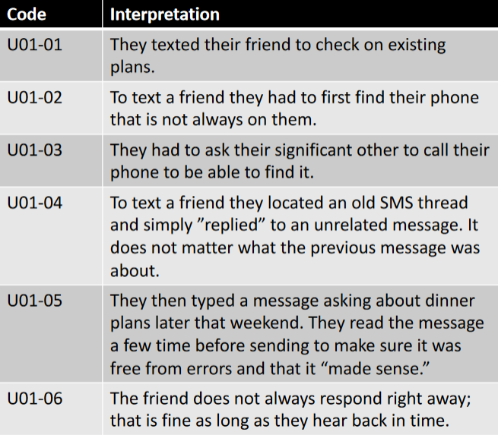
    - Ask participants confirmation questions to check whether my interpretation is correct
* Pitfalls
  + Participants are *not* re-performing the tasks during the interview, instead they just *describe* what tasks they performed to the interviewer
  + NO Hypothetical situations! If participant talked about anything they would do (i.e. hypothetical) then discard what they said and ask for specific instance
    - e.g. participants, sometimes I do … → discard this
* Additional Remarks
  + consider 2 people conducting the interview, one person ask questions, the other one takes notes
  + check out THU lecture recording at 56 min
* Example [THU Lecture 9/28]
  + Reflect on the different ways you take notes in class & describe the last time you took notes in class and show me the things you used to take notes
  + Participants responded with they take notes on their laptop
  + Ask them to show what they did on their laptop (e.g. their notes)
  + Do not immediately digress if there’s another potential area of discussion, keep with current flow first, and then later come back to the other branch of questions
  + Ask about what the lecture was happening when you were taking the notes
    - The lecturer would be another identity in the context of use
  + Show me the notes you were taking the at the time

Sequence Diagram/Model

* What
  + Documenting the sequence of steps the participant took to accomplish a goal or perform a sequence of tasks
    - Record different kinds of alternatives of participants’ tasks (multiple ways to do a task)
    - Also record different tasks
* How
  + 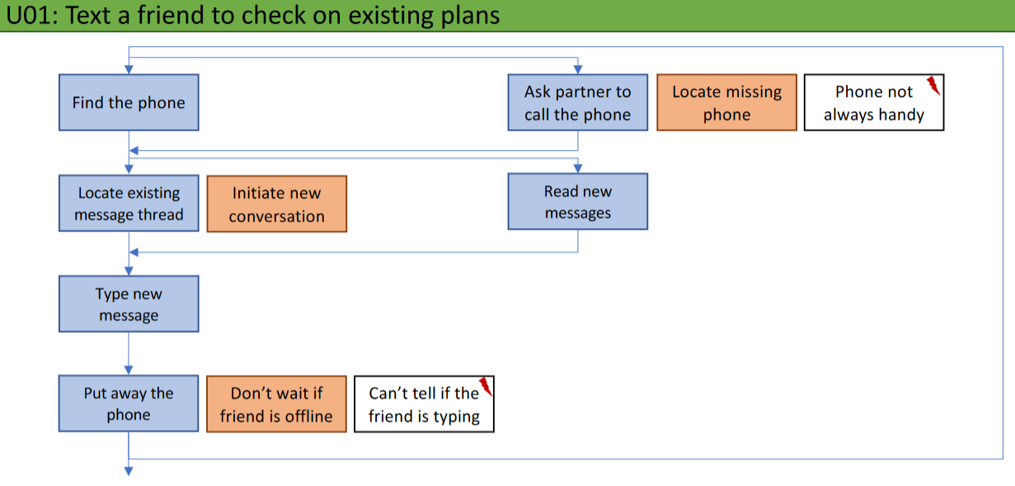
  + Green: Title the sequence with user code and the tasks/goal they performed
  + Blue: A single step (task) in a sequence of tasks participants performed (to accomplish some goal)
    - i.e. What participant did
    - Blue post-it notes at top left corner always indicates the first task
    - Connect the series of steps using arrows
    - If there is an alternative to a step, place the alternative parallel (horizontal) to that step
  + Red: Interpret why participant did a task (the intention behind it)
    - i.e. Why participant did it
    - put this note right next to the corresponding task (blue note)
  + White: Breakdown that corresponds to one specific interpretation (red) & one specific task (blue), immediately right next to the breakdown
    - *Undesirable* interactions
    - Less usable
    - Things that prevented or made it difficult to complete the task
* Pitfalls
  + The blue notes does NOT need to include all interpretations from the contextual inquiry; they only need to use the *tasks* participants did (a different way to present the interpretations)

Flow Diagram

* Ellipse = people (actors, stakeholders)
  + Different actors participants talked about during the contextual inquiry
  + The participant (user) always appears
  + Start with identifying the different actors and put them in the diagram
  + Give actors names that describes their relationship with the participant
* Rectangle = artifacts (technology)
  + Something used by the participant that carries the flow of information
* Arrow = flow of information
  + Indicate things that flow between different actors, either via the the artifacts or not
  + Label each arrow
    - either using another rectangle (specific), or
    - a short piece of text (abstract) right next to it
    - don’t worry about the distinction between the
* Red Lightning bolt: breakdown
* 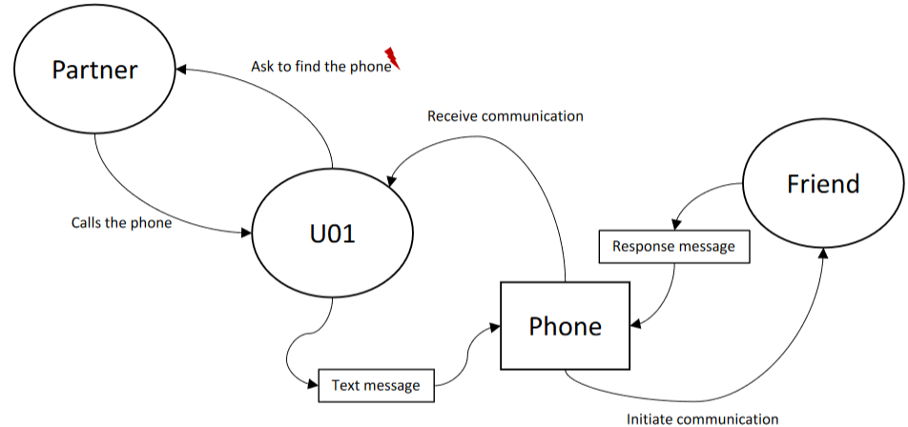

One-handed text entry is just a means to achieve some kind of goal; the user does not just wake up and wants to text with one hand; there must be a goal they want to achieve (e.g. search up something, reply a text message) but they just happened to do it with one hand

Group Instructions [check canvas]

* Consolidate your diagrams
* Create 1 affinity diagram
  + *Only* depends on the interpretations from individual components
  + Miro
* Come up with user requirements
  + May want to start with requirements individually and then consolidate them as a team
* Write report
  + Revise introduction and related works to make them more related to assignment 2
  + Methods
    - Same as individual, if we had done individual methods as a group
    - A table of participants w/ relevant demographic information
  + Results
    - Summarize the findings
    - Write about all the themes that have emerged in the affinity diagram
      * talk about each theme by itself and back it up with lower-level notes (e.g. interpretations, sections, etc.) in the affinity diagram
    - Reflect on different existing tasks users perform
      * refer to figures of consolidated sequence diagrams
    - Flow of information between different stakeholders
      * refer to the 1 consolidated flow diagram
  + User requirements
    - Come up with user requirements based on findings
    - Formally express the understanding of context of use in the form of user requirements, which should inform about the designs
    - Comprehensive
      * how well all of the requirements together cover the different aspects of the context of use
    - Objective
      * minimize ambiguity about whether certain solution satisfy this requirement
    - Testable
      * can be tested with some kind of experiment
    - Grounded in context of use
      * point directly back to the findings (specific aspects of context of use)
  + Discussions
    - Summarize the current understanding of the context of use based on the discoveries from the contextual inquiry
      * Can refer to specific findings from contextual inquiry or even the survey
    - Inform next steps

Combined/Consolidated Sequence Diagram

* 6 users/participants
* If different users performed similar tasks, then combine these sequence diagrams (of different users) into 1 diagram
  + i.e. kind of combining different users into 1 user
  + no more participants encoding

Same applies for consolidated Flow Diagram

Affinity Diagram

* Consolidate interpretations
* Step 1: Yellow Notes (Interpretations)
  + Put all interpretations gathered from the 5 contextual inquiries as yellow notes
  + 12-point font, fits on a 3x3 square post-it notes
* Step 2: Blue Notes (Categories)
  + Group the yellow notes based on similarity (affinity)
  + A Blue Note is created for each *group* of yellow notes to describe the category
  + Rule of thumb: Each blue note should have 3 – 5 yellow notes
* Step 3: Pink Notes (Theme)
  + A theme is created for different groups
  + Each pink note should have 3 – 5 blue notes
  + Theme should tell a story
    - Each theme is a separate section in the report (under results section)
    - Each blue note is a separate paragraph under the theme
    - Each yellow note is the evidence described in each paragraph
* Some yellow notes may be out of scope (may not fall under any blue notes), just leave them on the side